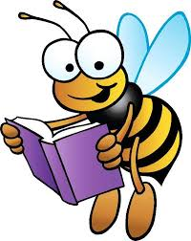
Hooray! You’ve finished a book!
Fill in the details below to get credit from your teacher.
Your name _____________ Date finished _______
Title of book ____________ Author __________
Parent Signature ______________
I’ve completed the Accelerated Reader quiz
I still need to complete the Accelerated Reader quiz

